Question1:

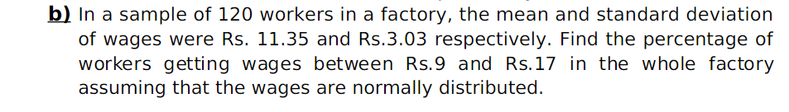

Question2

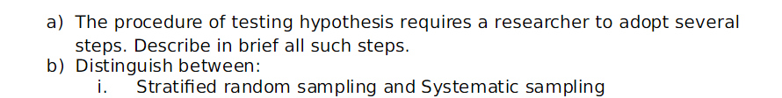

Question3



Question4:

You toss a fair coin three times:

1. What is the probability of three heads,
2. HHH
3. HHH?
4. What is the probability that you observe exactly one heads?
5. Given that you have observed *at least* one heads, what is the probability that you observe at least two heads?

Question5:

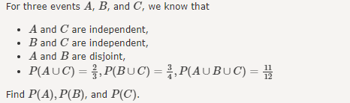

Question6-14 from this link will be there.

<https://www.sanfoundry.com/discrete-mathematics-questions-answers-multiplication-theorem-probability/>

From this link, please take questions

Question1,2,4,5,6,

Question 7,8,9,10